Learning Objectives

**After reading this chapter you should be able to:**

**LO1** Define the key terms of economics and opportunity cost and understand how a production possibilities frontier exemplifies the trade-offs that exist in life.

**LO2** Distinguish between increasing and constant opportunity cost and understand why each might happen in the real world.

**LO3** Analyze an argument by thinking economically, while recognizing and avoiding logical traps.

Chapter Outline

* Economics and Opportunity Cost
* Modeling Opportunity Cost Using the Production Possibilities Frontier
* Attributes of the Production Possibilities Frontier
* Economic Growth
* The Big Picture
* Kick It Up a Notch: Demonstrating Constant and Increasing Opportunity Cost on a Production Possibilities Frontier

ECONOMICS AND OPPORTUNITY COST

* **Economics**: the study of the allocation and use of scarce resources to satisfy unlimited human wants

*Teaching Tips*

1. *Break out the definition word-by-word. (study, allocation, scarce, resources, unlimited, human wants)*
2. ***Let students discuss*** *the things they think are free (air, ocean water) and get them to see that fresh air and unpolluted ocean water are not free.*
3. *Use the definition to note that all economic systems (free markets, socialism, communism, etc.) must deal with scarcity.*

## Choices Have Consequences

* Opportunity Cost
* The forgone alternative of the choice made

Or

* What you would have done had you not done what you did.

*Teaching Tips*

1. ***Let students discuss*** *what they would be doing were they not in class.*
2. ***Let students discuss*** *what they would be doing if they were not in college.*
3. *Note for them that irresponsible behavior and responsible behavior both have an opportunity cost.*
4. ***Let students discuss*** *the opportunity cost of going to college. Get them to see the opportunity cost of going to college includes both the tuition they pay as well as the income they forgo by being less able to work large numbers of hours.*

MODELING OPPORTUNITY COST USING A PRODUCTION POSSIBILITIES FRONTIER

* **PPF:** a graph which relates the amounts of different goods that can be produced in a fully employed society
* **Model:** a simplification of the real world that we can manipulate to explain the real world.
* **Simplifying Assumption:** an assumption that may, on its face, be silly but allows for a clearer explanation
* **Scarce:** not a freely available and infinite
* **Resources:** anything we either consumer directly or use to make things that we will ultimately consume

The Starting Point for a PPF

**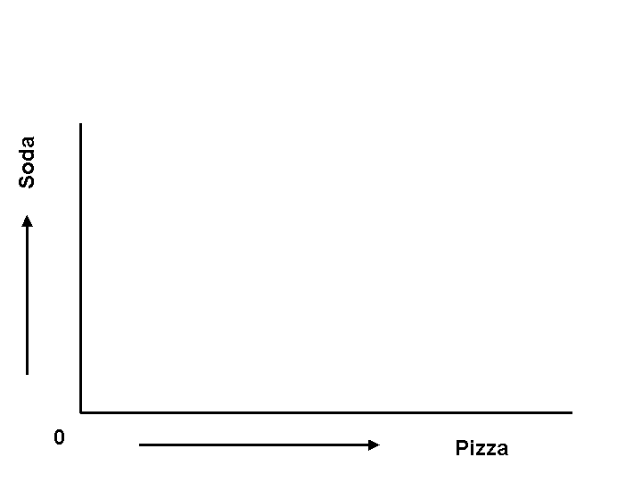**

*Drawing Tips*

1. *Use this as an opportunity to review the idea of graphing. (Students may not have had a math course in years and those who are math-phobic are often those who are econ-phobic.)*
2. *Draw the axes, labeling them and using the arrows to illustrate and emphasize the idea that moving further to the right implies more pizza is produced and moving higher means more soda is produced.*

**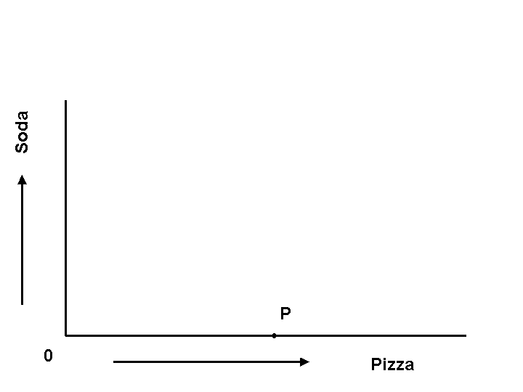**

*Drawing Tip*

*Add the point “P”.*

*Teaching Tips*

1. *Note that this point represents the most pizza that can be produced.*
2. *Note that this is a finite amount.*

**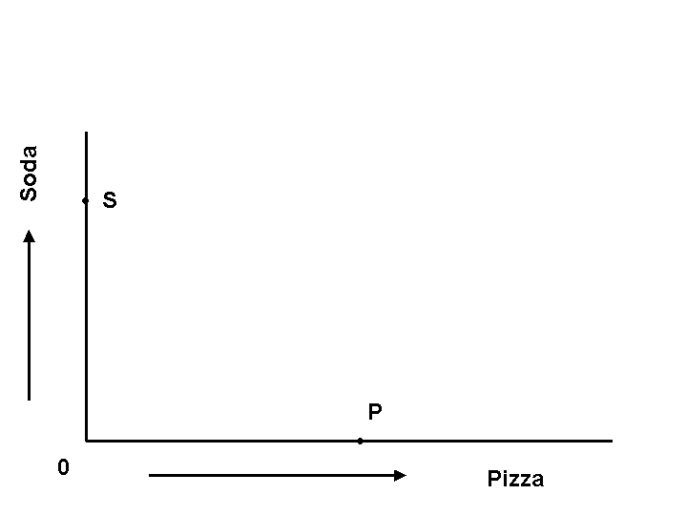**

*Drawing Tip*

*Add the point “S”.*

*Teaching Tips*

1. *Note that this point represents the most soda that can be produced.*
2. *Note that this is a finite amount.*

Points in Between the Extremes of a PPF

*Drawing Tip*

*Put a point “X” that is around a third of the horizontal distance from the origin to point “P” and only a small distance vertically lower than point “S”.*

*Teaching Tip*

*Use the idea that the best person to switch from soda to pizza is the “pizza chef”.*

**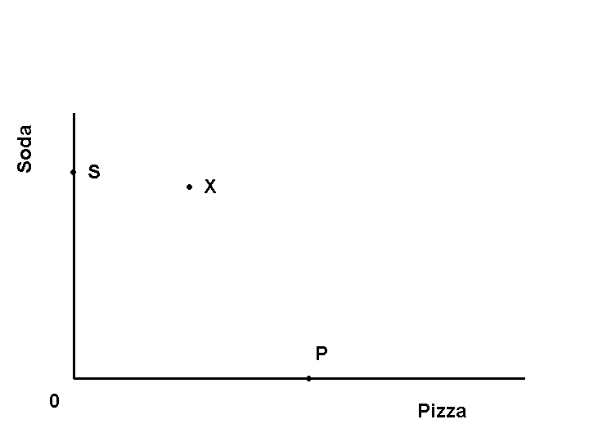**

**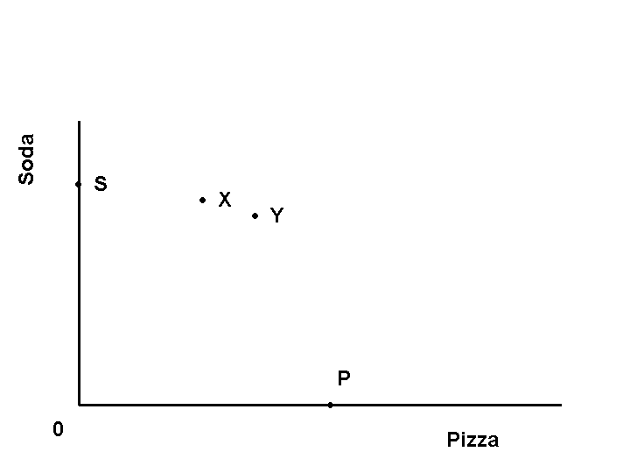**

*Drawing Tips*

1. *Put a point “Y” down and to the right of “X”.*
2. *Make sure the point represents more of a loss of soda than the change from “S” to “X” and less of a gain of pizza than from “S” to “X”.*

*Teaching Tip*

*Explain that the next best pizza maker/next worst soda maker is the best person to move next.*

**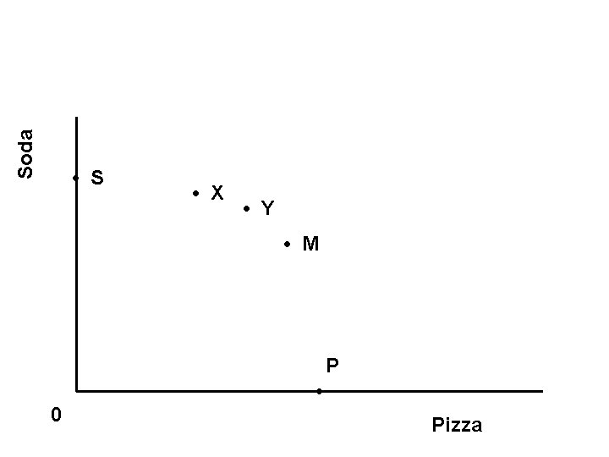**

*Drawing Tips*

1. *Put a point “M” down and to the right of “Y”.*
2. *Make sure the point represents more of a loss of soda than the change from “X” to “Y” and less of a gain of pizza than from “X” to “Y”.*

*Teaching Tip*

*Explain that the next best pizza maker/next worst soda maker is the best person to move next.*

**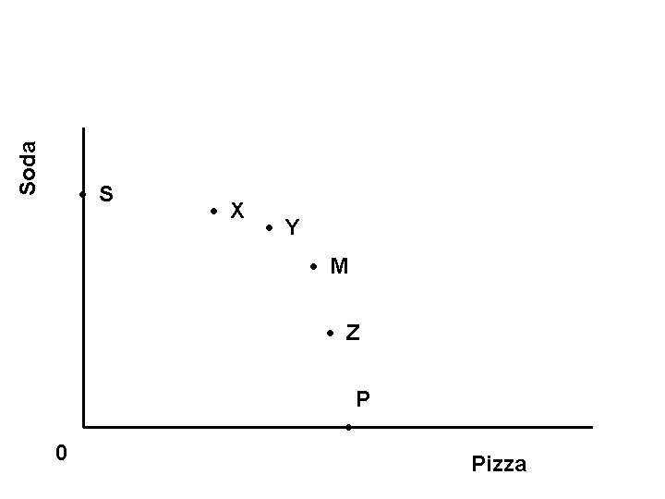**

*Drawing Tips*

1. *Put a point “Z” down and to the right of “M”.*
2. *Make sure the point represents more of a loss of soda than the change from “Y” to “M” and less of a gain of pizza than from “Y” to “M”.*

*Teaching Tip*

*Explain that you could have gone the other way starting at point “P” and moving toward point “S”.*

ATTRIBUTES OF THE PRODUCTION POSSIBILITIES FRONTIER

A Fully Labeled Production Possibilities Frontier: The Case When People are Different

*Drawing Tip*

*Connect the dots.*

**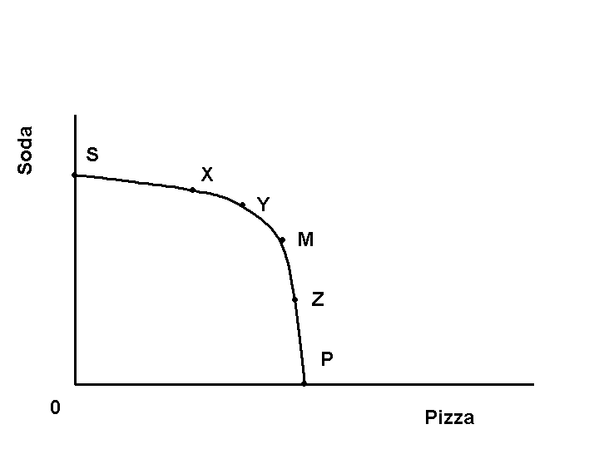**

**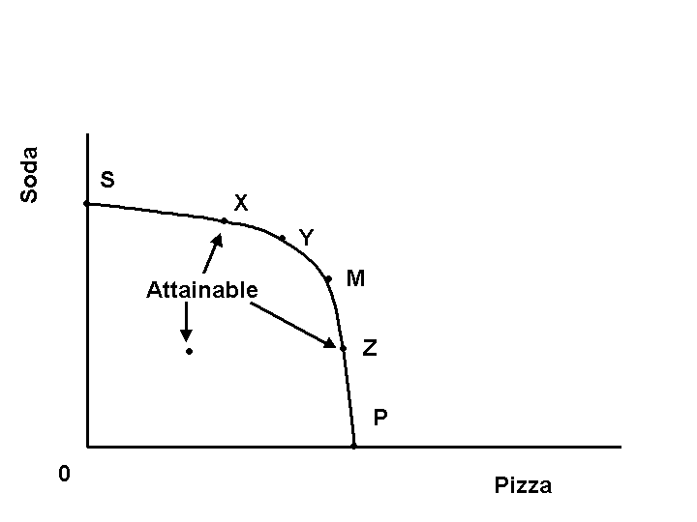**

*Teaching Tips*

1. *Note that points on the curve are attainable.*
2. *Note that points on the interior are also attainable*.

*Teaching Tip*

*Note that points on the exterior are unattainable.*

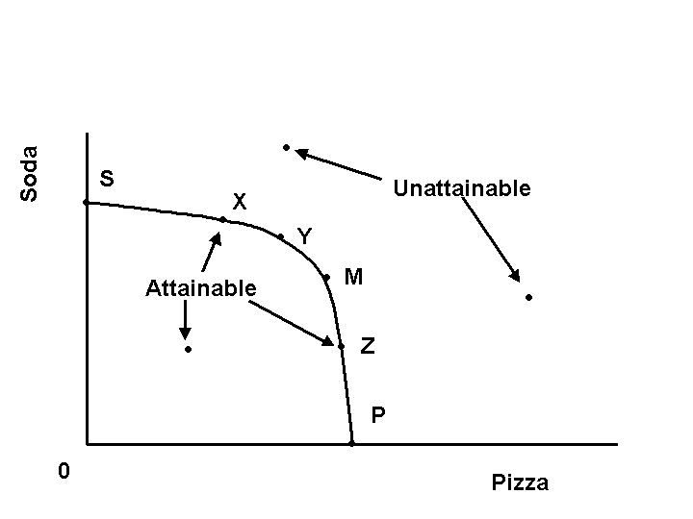

**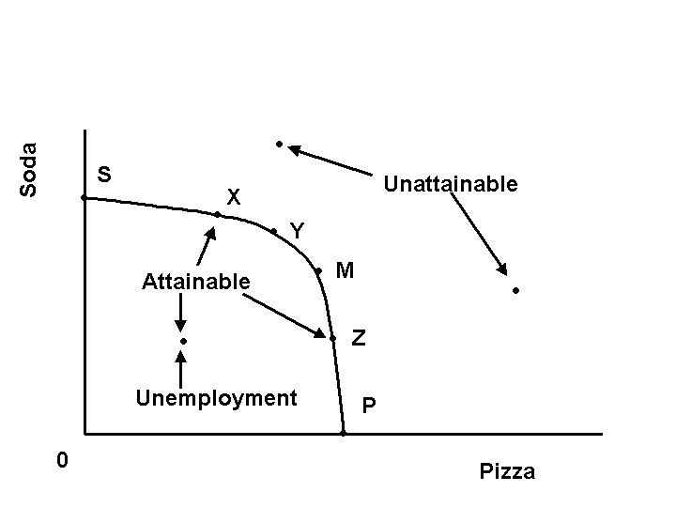**

*Teaching Tips*

1. *Note that points on the interior are ones in which there is unemployment.*
2. *Note that more can be produced of either or both goods with the existing resources.*

**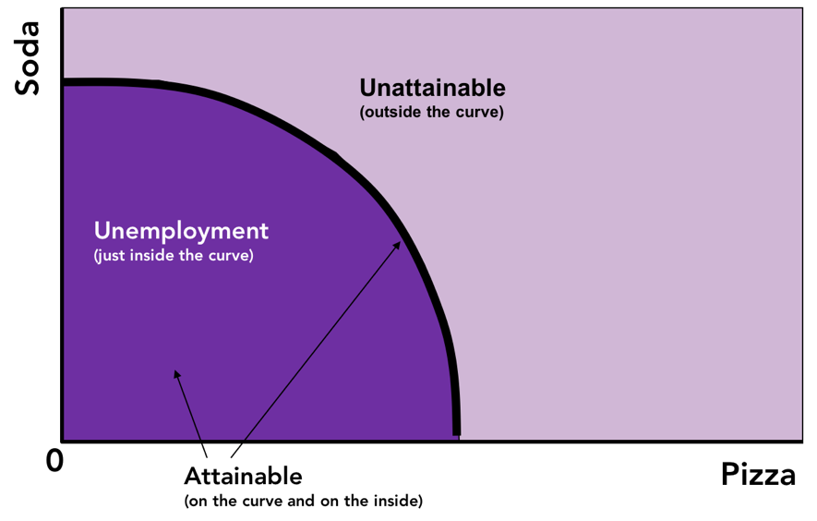**

A Fully Labeled Production Possibilities Frontier: The Case When People are the Same

*Drawing Tips*

1. *Draw each point one by one.*
2. *Explain the constancy of the loss of soda and gain of pizza as you progress from “S” to “P”.*

*Teaching Tips*

1. *Give examples of situations where there is constant opportunity cost.*
2. ***Let students discuss*** *situations where they can see constant opportunity cost in the real world.*

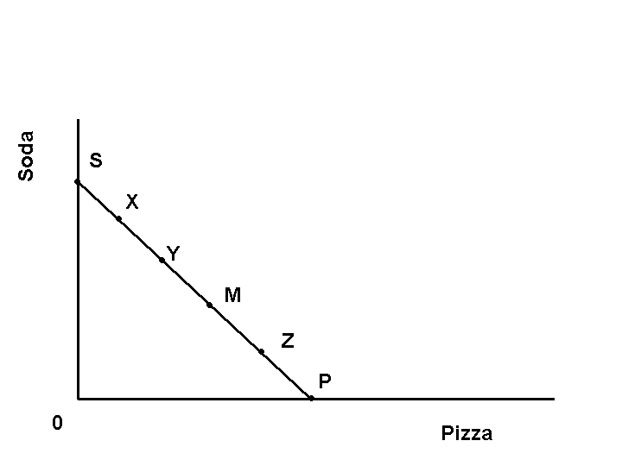

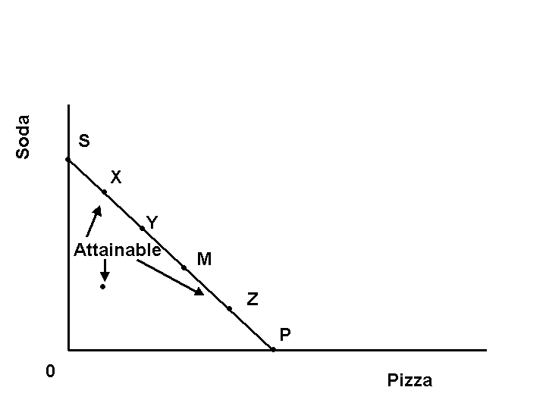

*Teaching Tips*

1. *Note that points on the curve are attainable.*
2. *Note that points on the interior are also attainable*.

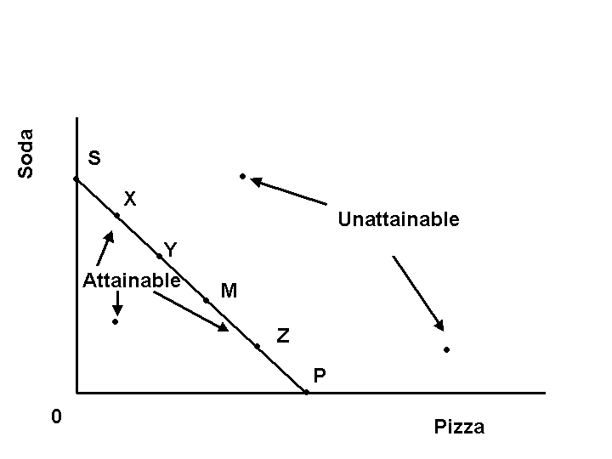

*Teaching Tip*

*Note that points on the exterior are unattainable.*

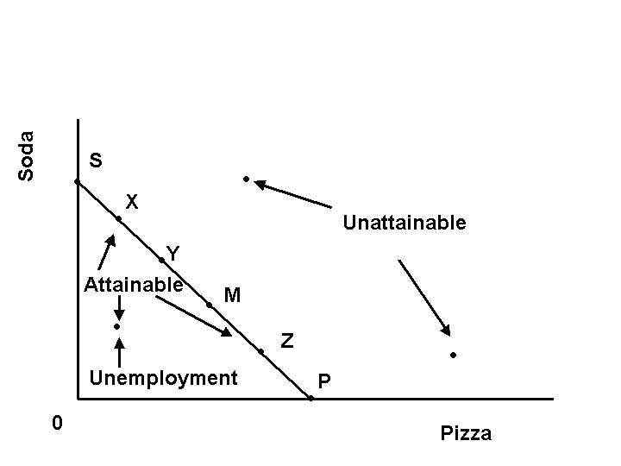

*Teaching Tips*

1. *Note, just like the increasing opportunity cost case, that points on the interior are ones in which there is unemployment.*
2. *Note, just like the increasing opportunity cost case, that more can be produced of either or both goods with the existing resources.*

# ../../../../Desktop/PPF_Constant_Opp_Cost.png

# Increasing and Constant Opportunity Cost

* **Increasing Opportunity Cost**
* exists when the additional resources required to produce an additional unit grows as more output is produced.
* likely to occur when people are different in their skills.
* **Constant Opportunity Cost**
* exists when the additional resources required to produce an additional unit remains the same as more output is produced.
* likely to occur when people are identical in their skills.

*Teaching Tips*

1. *Be sure to differentiate increasing opportunity cost with the level simply being greater. (The opportunity cost of producing 3 units of pizza is obviously greater than producing only 2, but the idea of increasing opportunity cost is that producing the third unit had a greater opportunity cost of producing the second.*
2. ***Let students discuss*** *the likelihood of finding increasing opportunity cost in the real world. Have them generate examples.*
3. ***Let students discuss*** *the likelihood of finding constant opportunity cost in the real world. Have them generate examples.*

ECONOMIC GROWTH

* **Generalized Growth:** an increase in, or an increase in the ability of, resources to produce all goods
* **Specialized Growth:** an increase in the ability to produce a particular good because there is an increase in, or an increase in the ability of, resources to produce a particular good

*Teaching Tip*

***Let students discuss*** *by providing examples of technologies/innovations that would create generalized growth. Do the same for specialized growth. Have them indicate an example of an output and an innovation in combination. For instance, robotics would enable assembly-line production of cars but not the production of music. Computer software enhancements would impact both cars and music.*

Modeling Specialized and Generalized Growth

**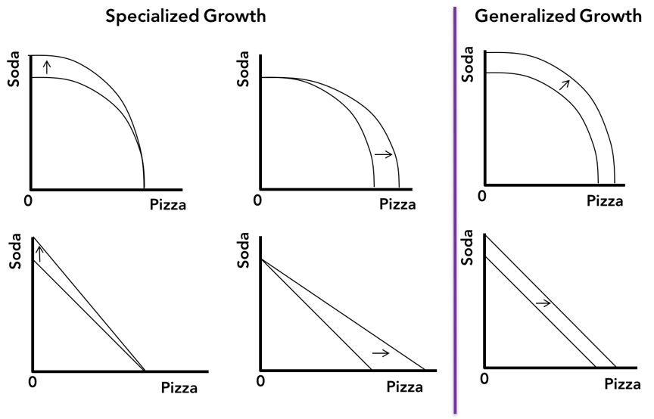**

*Teaching Tip*

*Use the examples provided in the previous discussion to alter the axes labels and to tell the story.*

Sources of Economic Growth

* Increase in the availability of resources
* Increase in the ability of resources

*Teaching Tips*

1. *This is an excellent time to discuss recent innovations like hydraulic fracturing (which increases the availability of energy) as opposed to increases in educational attainment (which increases the ability of resources).*
2. *A reference to Gordon’s “Rise and Fall of American Growth” could be useful. Electric lighting had an impact of making more “time” available for production. Education makes labor more productive. The change in societal standards that increased the prevalence of women in the labor market is analogous to the increased accessibility of natural gas fields with hydraulic fracturing in that the resources were always there, they were just not utilized in production.*

THE BIG PICTURE

* **Circular Flow Model:** A model that shows the interactions of all economic actors
* Markets are where the interactions take place.
* Actors are the entities interacting.

Markets in a Circular Flow Diagram

* **Market:** any mechanism by which buyers and sellers negotiate an exchange
* **Factor Market:** a mechanism by which buyers and sellers of labor and financial capital negotiate an exchange
* **Goods and Services Market:** a mechanism by which buyers and sellers of goods and services negotiate an exchange
* **Foreign Exchange Market:** a mechanism by which buyers and sellers of the currencies of various countries negotiate an exchange

Actors in a Circular Flow Diagram

* + Households
  + Firms
  + Government

The Circular Flow Diagram

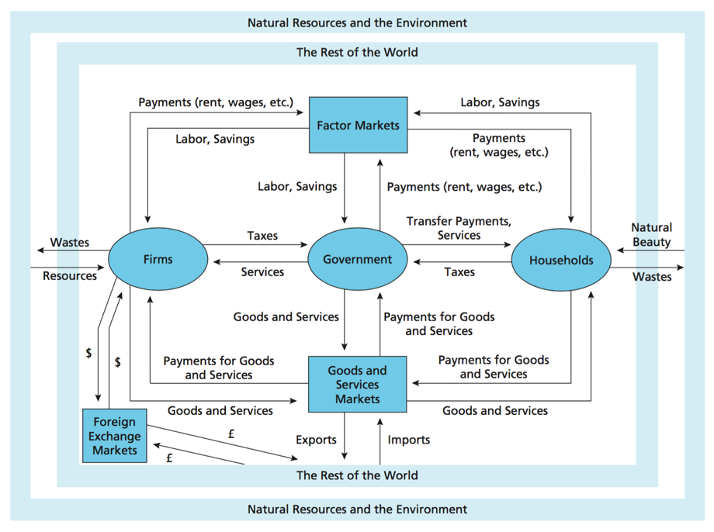

*Teaching Tip*

*In my mind, this is a topic that is either eminently skippable or worthwhile (but only when done well). It is way too complicated to do half-heartedly.*

THINKING ECONOMICALLY

### Marginal Analysis

* **Optimization Assumption:** an assumption that suggests that the person in question is trying to maximize some objective
* **Marginal Benefit:** the increase in the benefit that results from an action
* **Marginal Cost**: the increase in the cost that results from an action
* **Net Benefit:** the difference between all benefits and all costs

*Teaching Tips*

1. *Emphasize the importance of this concept as it will relate to companies choosing output, and people deciding how many goods to buy.*
2. *Referring to the GPA-Fun tradeoff (from Kick It Up a Notch, page 15),* ***let students discuss*** *the marginal benefit and marginal cost of studying on Thursday afternoon relative to Saturday night.*

### Positive and Normative Analysis

* **Positive Analysis**: a form of analysis that seeks to understand the way things are and why they are that way
* **Normative Analysis:** a form of analysis that seeks to understand the ways things should be

*Teaching Tips*

1. *Give several examples of each type of analysis.* 
   1. *“How much the rich pay in federal taxes vs. how much they should pay.”*
   2. *“What does welfare do to work incentives vs. should welfare recipients be forced to work.”*
2. *Give your own examples how economists could have disagreements regarding “positive” analysis. For instance, economists differ on the impact of the minimum wage frequently because they are using different methods of estimating the impact.*

###### Economic Incentives

* **Incentive:** something that influences the decisions we make
* Examples: prices influence the amount we buy; taxes influence how much we work and save

###### Logical Flaws

* **Fallacy of Composition:** the mistake in logic that suggests that the total economic impact of something is always and simply equal to the sum of the individual parts
* **Correlation = Causation:** the mistake that suggests that because two variables are correlated that one caused the other to happen

*Teaching Tips*

1. *Use the cake vs. the ingredients example in the text.*
2. ***Let students discuss*** *to see if they can generate examples of their own.*
3. *Explain the difference between direct and inverse correlation.* 
   1. *Direct Correlation: the statistical observation that when two variables vary together*
   2. *Inverse Correlation: the statistical observation that when two variables vary in opposite directions*
4. *Give an example where correlation and causation ARE the same such as, “when you turn on the stove the element gets hot.”*
5. *Give an example where you give the reverse causation, “people swimming outside must make it hot.”*
6. *Given an example where they are NOT the same such as the weight-dates example in the book. This example also illustrates the “other missing variable issue”, that is age is correlated with both and age determines the frequency of dates for teens, not weight.*

Kick It Up a Notch: DEMONSTRATING CONSTANT AND INCREASING OPPORTUNITY COST

Demonstrating Increasing Opportunity Cost

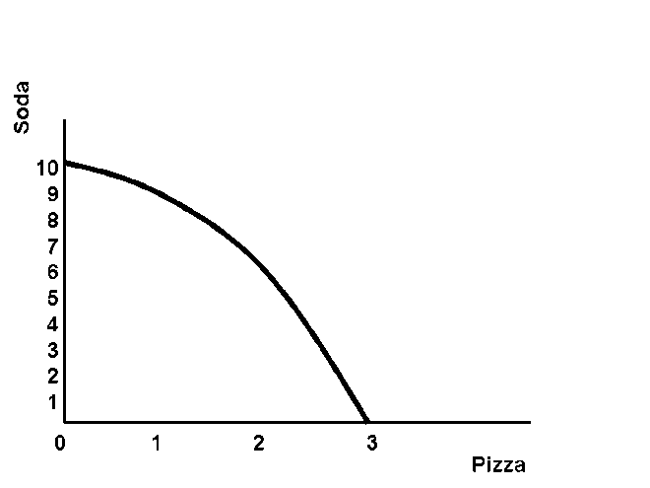

*Drawing Tip*

*Draw a bowed-out production possibility frontier, and label the horizontal axis evenly across in thirds.*

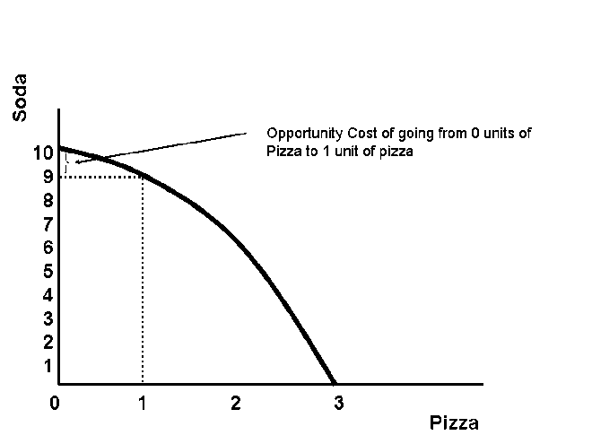

*Drawing Tips*

1. *Mark up from 1 unit of pizza to the curve and over to the vertical axis.*
2. *Mark the distance from the point where only soda is produced to the dotted line just drawn as the opportunity cost of going from 0 units of pizza to 1 unit.*

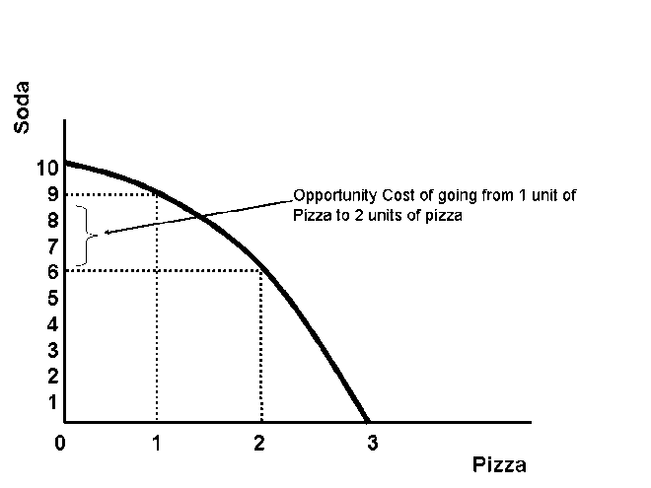

*Drawing Tips*

1. *Mark up from 2 units of pizza to the curve and over to the vertical axis.*
2. *Mark the distance from the previous dotted line to the dotted line just drawn as the opportunity cost of going from 1 unit of pizza to 2 units.*

**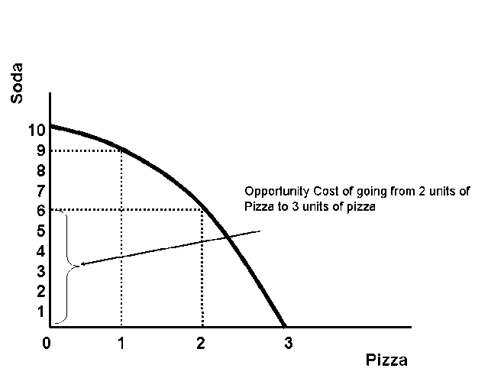**

*Drawing Tips*

1. *Mark up from 3 units of pizza to the curve and over to the vertical axis.*
2. *Mark the distance from the previous dotted line to the dotted line just drawn as the opportunity cost of going from 2 units of pizza to 3 units.*

*Teaching Tips*

1. *Use the example of the tradeoff between a good GPA and the fun you can have in college. Draw a PPF with these as the goods. Use the maximum GPA point to talk about the best they could do if they studied all the time (it may not be a 4.0). Note that people may have different PPFs depending on how “smart” they are.*
2. ***Let students discuss*** *the optimal study time-fun time strategy for themselves. Steer them toward the idea that not much “fun” happens while class is going on and that if they confine their fun to Friday and Saturday night they could have a great deal of fun and have a good GPA.*

Demonstrating Constant Opportunity Cost

**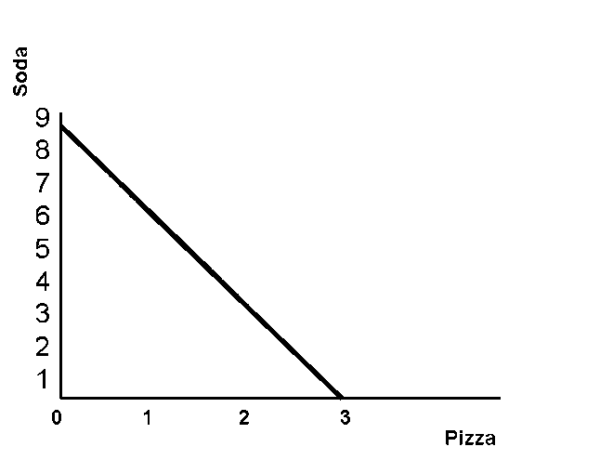**

*Drawing Tip*

*Draw a linear production possibility frontier and label the horizontal axis evenly across in thirds.*

**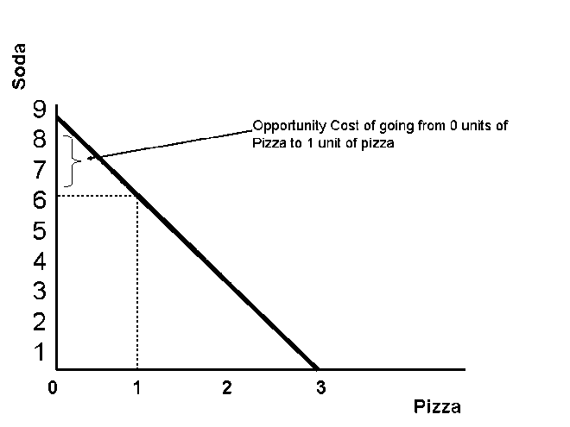**

*Drawing Tips*

1. *Mark up from 1 unit of pizza to the curve and over to the vertical axis.*
2. *Mark the distance from the point where only soda is produced to the dotted line just drawn as the opportunity cost of going from 0 units of pizza to 1 unit.*

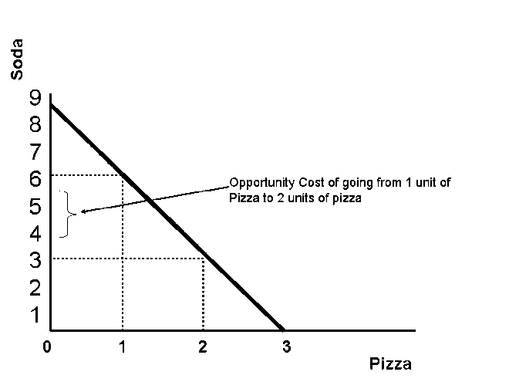

*Drawing Tips*

1. *Mark up from 2 units of pizza to the curve and over to the vertical axis.*
2. *Mark the distance from the previous dotted line to the dotted line just drawn as the opportunity cost of going from 1 unit of pizza to 2 units.*

*Drawing Tips*

1. *Mark up from 2 units of pizza to the curve and over to the vertical axis.*
2. *Mark the distance from the previous dotted line to the dotted line just drawn as the opportunity cost of going from 2 units of pizza to 3 units.*

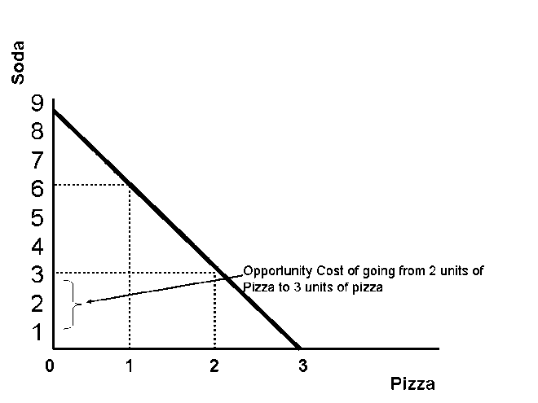

End of Chapter Questions

**Quiz Yourself**

1. Scarcity implies that the allocation scheme chosen by society can

a) not make more of any one good.

b) always make more of any good.

**c) typically make more of a good but at the expense of making less of another.**

d) always make more of all goods simultaneously.

Explanation: Scarcity implies that choices involve trade-offs.

2. A production possibilities frontier is a simple model of

**a) scarcity and allocation.**

b) prices and output.

c) production and costs.

d) inputs and outputs.

Explanation: The production possibilities frontier shows the quantity of two goods that can be produced. It implies that scarcity requires that choices be made as to how to use resources.

3. The underlying reason that there are unattainable points on a production possibilities frontier diagram is that there

a) is government.

b) are always choices that have to be made.

**c) is a scarcity of resources within a fixed level of technology.**

d) is unemployment of resources.

Explanation: The points outside the production possibilities frontier are unattainable. This means that currently available resources and technology are insufficient to produce amounts greater than those illustrated on the frontier. On a graph, everything beyond the frontier is unattainable.

4. The underlying reason production possibilities frontiers are likely to be bowed out (rather than linear) is

a) choices have consequences.

b) there is always opportunity costs.

**c) some resources and people can be better used producing one good rather than another.**

d) there is always some level of unemployment.

Explanation: If the production possibilities frontier is not a line but is bowed out away from the origin, then opportunity cost is increasing. The reason for this is that as we add more resources to the production of, for example, pizza, we are using fewer resources to produce soda. Compounding that problem, at each stage as we take the resources away from soda and put them into pizza, we are moving workers who are worse at pizza production and better at soda production than those moved in the previous stage. This means that the increase in pizza production is diminishing and the loss in soda production is increasing. An economist would call this an example of increasing opportunity cost. If the production possibilities frontier is a straight line that is not bowed out away from the origin, then opportunity cost is constant.

5. The optimization assumption suggests that people make

a) irrational decisions.

b) unpredictable decisions.

**c) decisions to make themselves as well off as possible**.

d) decisions without thinking very hard.

Explanation: The optimization assumption suggests that the person in question is trying to maximize some objective. Consumers are assumed to be making decisions that maximize their happiness subject to a scarce amount of money.

6. Imagine an economist ordering pizza by the slice. When deciding how many slices to order she would pick that number where the enjoyment of the \_\_\_\_\_ equals the enjoyment she could get from using the money on another good.

a) first slice

**b) last slice**

c) average slice

d) total number of slices

Explanation: The enjoyment of the last slice is the marginal benefit of that slice. If this enjoyment is more than the enjoyment from some alternative, more will be consumed.

7. Of course, all individual students are better off if they get better grades. If you were to conclude that all students would be better off if everyone received an A you would

a) have fallen victim to the fallacy of scarcity.

b) be right.

**c) have fallen victim to the fallacy of composition.**

d) be mistaking correlation with causation.

Explanation: The fallacy of composition is the mistake in logic that suggests that the total economic impact of something is always and simply equal to the sum of the individual parts.

8. If you were to conclude, after carefully examining data and using proper evaluation techniques, that a tax credit for attending college benefits the poor more than a tax deduction (of equal total cost to the government) would, you would have engaged in \_\_\_\_\_\_\_\_\_ analysis to reach that conclusion.

a) negative

**b) positive**

c) normative

d) creative

Explanation: Economists, and social scientists in general, distinguish views of “the way things are” from “the way things should be,” calling the former positive analysis and the latter normative analysis. Positive analysis is a form of analysis that seeks to understand the way things are and why they are that way. Normative analysis is a form of analysis that seeks to understand the way things should be.

**Short Answer Questions**

1. Suppose you buy a new car. What is the opportunity cost of doing so?

2. Suppose you decided to study all last week for this exam instead of doing anything fun. What was the opportunity cost of doing so? Why might the opportunity cost (defined in terms of fun lost) be expected to increase?

3. Suppose you hear a political candidate claim credit or lay blame for an economic outcome. How can you tell whether the candidate is correct? What would you need to know?

4. If you get a 25 percent pay increase, you are better off. Explain why some people would not be better off if their employer gave them a 25 percent pay increase.

5. Suppose you were to analyze the state and the economy at the moment. You say to your friends, “The economy has been growing more slowly in the last 10 years than it did in the previous 20 years. The government should cut taxes to stimulate the economy.” What portion of that statement is “positive” and what portion of that statement is “normative?”

**Think about This**

What was your opportunity cost of attending college?

Think about the most expensive thing that you have ever purchased. What could you have done with the money? Which outcome would have made you better off—what you did or what you could have done?

Think about the last time you took a series of tests during a short period of time (high school or college finals work here). How did you decide how much time to spend on each subject? How might the study of economics help you make that allocation decision in the future?

**Talk about This**

Discuss whether you believe people make rational decisions based on the optimization assumption.

Discuss what kinds of noneconomic (something you would normally not think of as an economic decision) trade-offs could be modeled with a production possibilities frontier?

**Dot-to-Dot**

The two graphs below are old-fashioned dot-to-dots. I used them for the first time in the Fall 2003 semester and they were amazingly effective in getting students comfortable with drawing the graphs. They should be used after explaining the concepts and after you have talked about some of the mechanics. They seemed to help students become more comfortable with the steps of drawing a graph.

